

Port Moody Police Department
Media Release

FILE: 2015-6526

DATE: November 18, 2015

SUBJECT: Abduction and release of teenage girl

AUTHOR: Cst. Luke van Winkel

Port Moody Police are currently investigating the abduction and release of a local 14-year-old girl.

On November 17, 2015 at approximately 3:20 p.m., a 14-year-old girl was walking home alone in the 1300-block of David Avenue when she was allegedly grabbed and pulled into a van. She was subsequently kept in the van as it drove around for one and a half hours before being released, unharmed, in the 3000-block of Lougheed Highway in Coquitlam. The girl was not harmed nor was any of her property stolen.

The van was described as a white newer model Mercedes Sprinter van (similar to the image below).

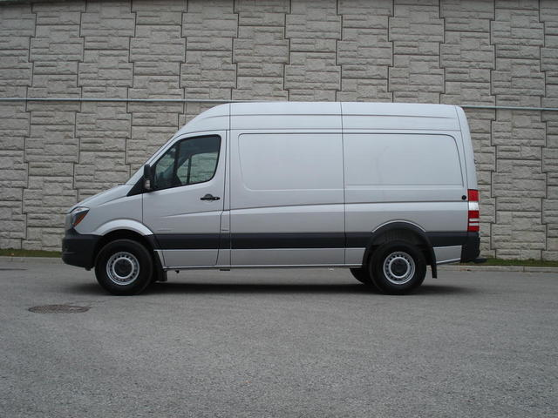

The suspects were unknown to the victim and are described as follows:

Suspect #1 – Abductor
Caucasian male between 25 and 30 years of age with possibly olive skin, 6’4” tall, weighing over 200 pounds, with long brown hair and a muscular athletic build, wearing a white sweatshirt with a red maple leaf on the left arm, black pants and black shoes.

Suspect #2 – Abductor
Caucasian male between 25 and 30 years of age with possibly olive skin, 5’7” to 5’8” tall, weighing over 200 pounds, short light brown hair and a muscular athletic build (possibly a bodybuilder), short dirty blonde beard and a black mark on the right side of his neck (possibly a tattoo), wearing black pants and a greyish/white sweatshirt.

Suspect #3 – Driver
Unknown ethnicity male, wearing a blue Toronto Blue Jays baseball cap

The investigation into this matter is ongoing and we will provide further information as it becomes available. The release of this information has been delayed due to investigative steps being undertaken by the Port Moody Police Department’s Major Crime Section. The PMPD would like to ensure all parents and students that their safety is paramount and that police across the district have been made aware of the incident and police presences were increased around schools during dismissal time. Police have informed School District 43 of the incident and they are working with police on the matter.

Anyone with information about this incident is asked to contact the Port Moody Police Department at 604-461-3456 or Crime Stoppers at 1-800-222-8477.

